**Kyrie Irving Mall**

**User Manual**

**Developed by:**

**Jianmu Deng**

**December 11, 2018**

Content

1. Introduction: 3

2. Function: 3

2.1 Register: 3

2.2 Login: 4

2.3 Browser: 4

2.4 Search: 5

2.5 Cart: 6

2.6 Purchase: 7

2.7 Order: 8

## Introduction:

Greetings, my dear customer. This document helps you enjoy Kyrie Irving Mall better. You can find the following information here: register, login, browser, search, cart, purchase, order and personal information. Enjoy yourself!

## 2. Function:

## 2.1 Register:

Kyrie Irving Mall only serves for register customer. If you like Kyrie, join us as soon as possible! You can click “Register” link which locates top right of each web page. Shown as figure 1.

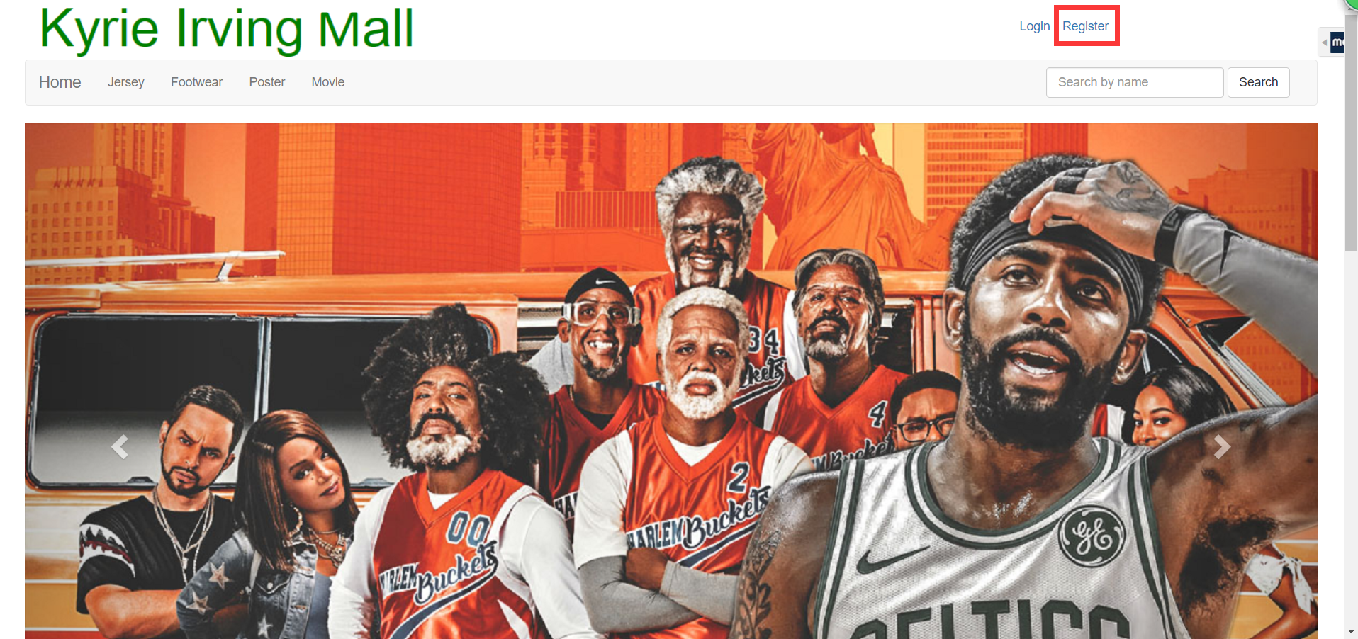

**Figure 1**

After click “Register” link, you will enter the register page. Just a reminder, all the personal information you should better enter by correct format, if not there will be some tips for you when you got a mistake. Shown as figure 2.

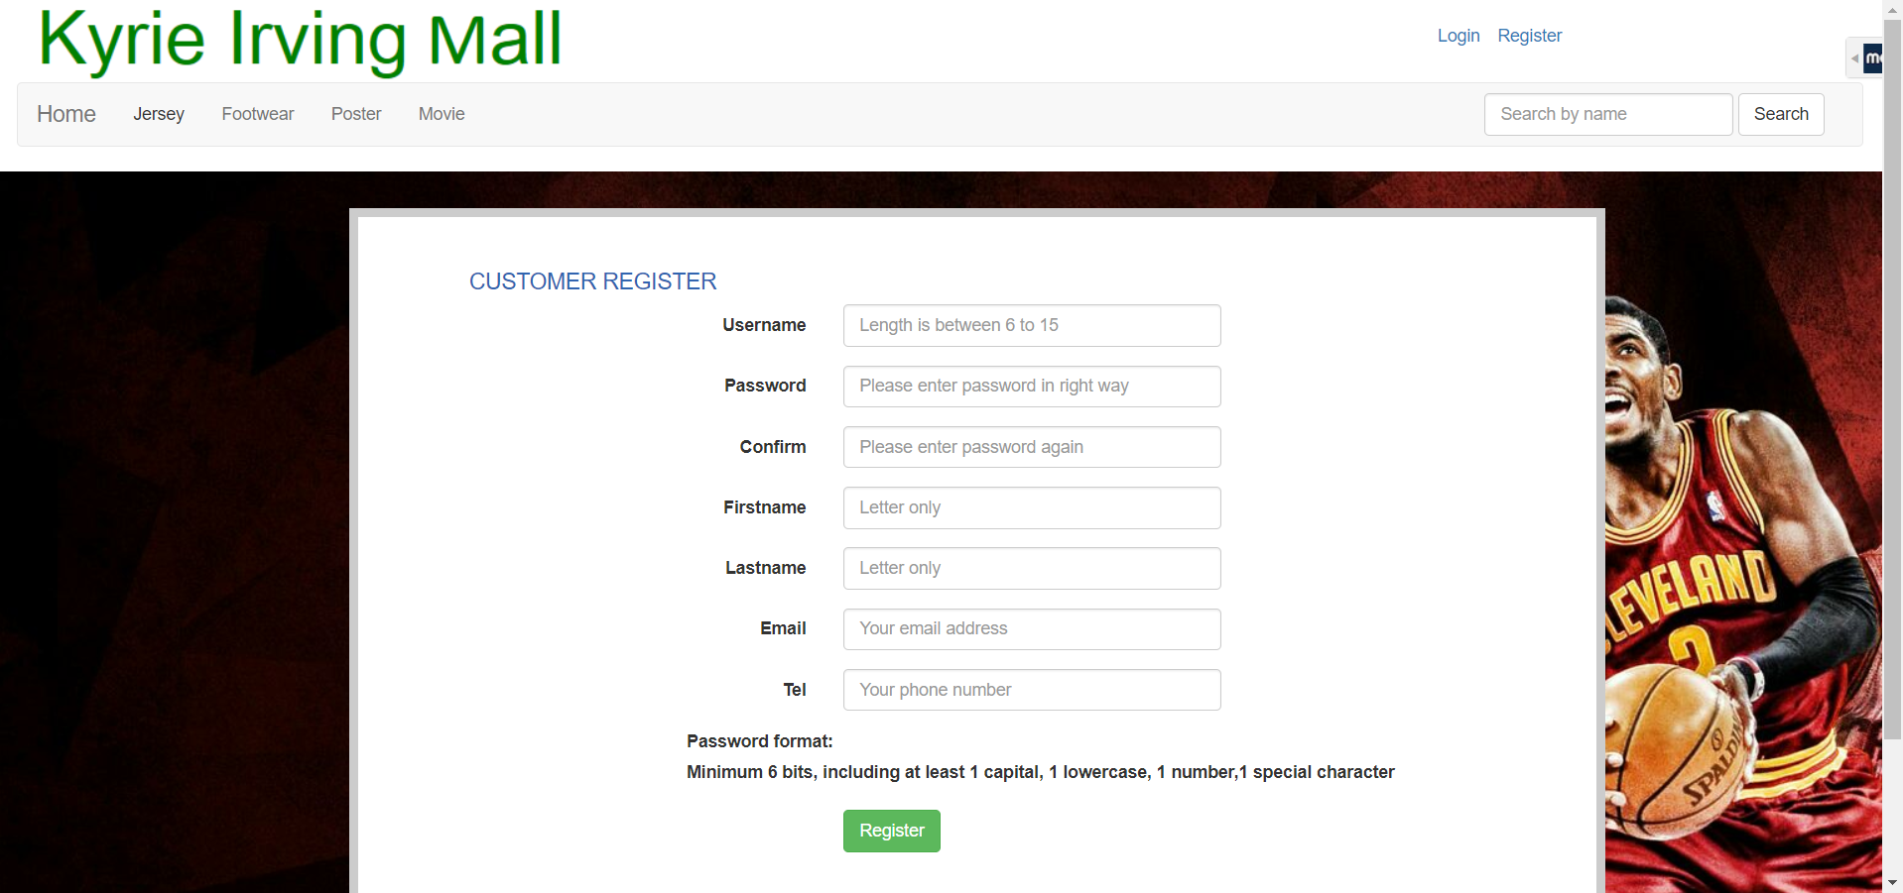

**Figure 2**

If you register successful, the page will jump to register page automatically.

## 2.2 Login:

After you registered, you can click “Login” link which locates top right of each web page. Shown as figure 3.

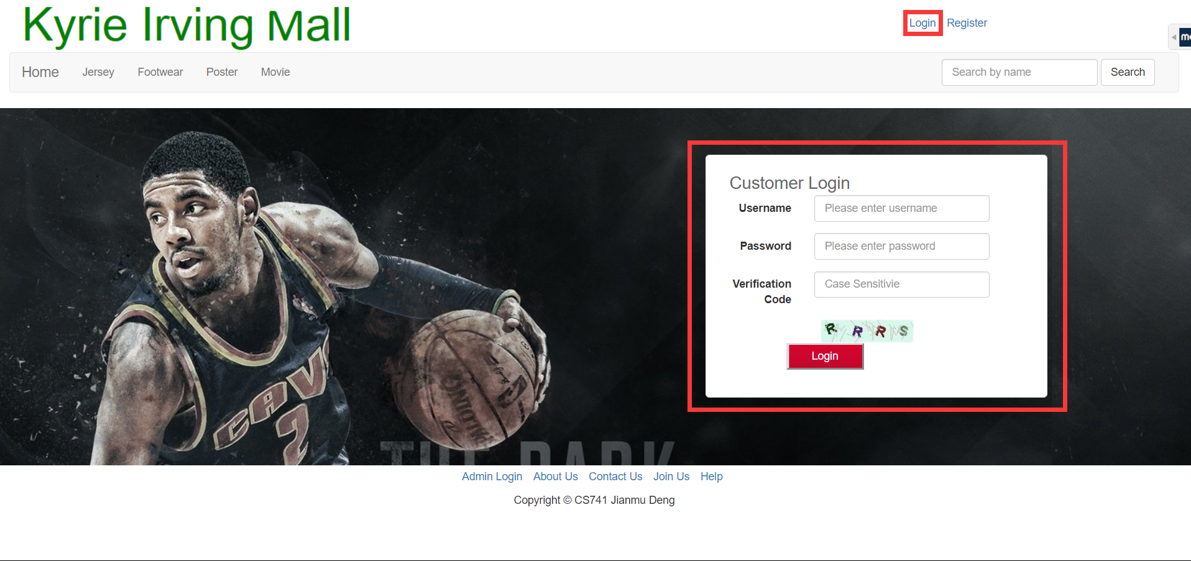

**Figure 3**

After you login, there will display more link on the top right of each page.

## 2.3 Browser:

Whatever you are guest or register customer all can browsers item of this mall. There are total four types of items you can buy. You can see them at the navigation bar. Shown as figure 4.

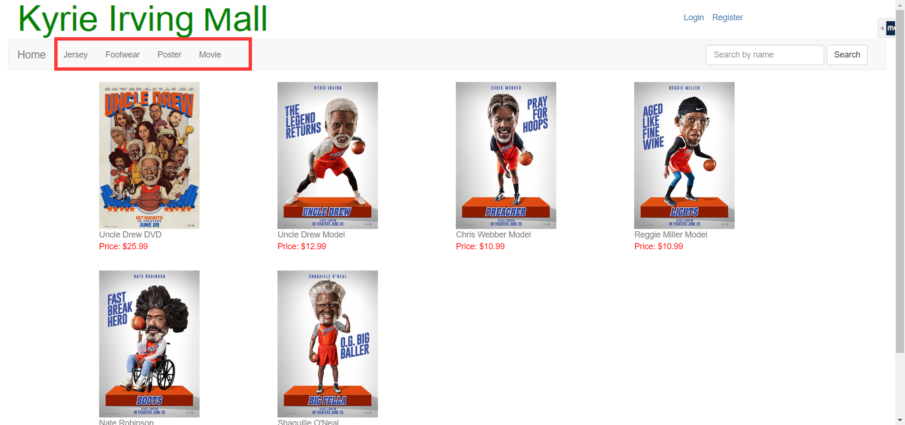

**Figure 4**

You can also view details of items when you click the picture or name of items. Shown as figure 5. And you can add item into your cart after login.

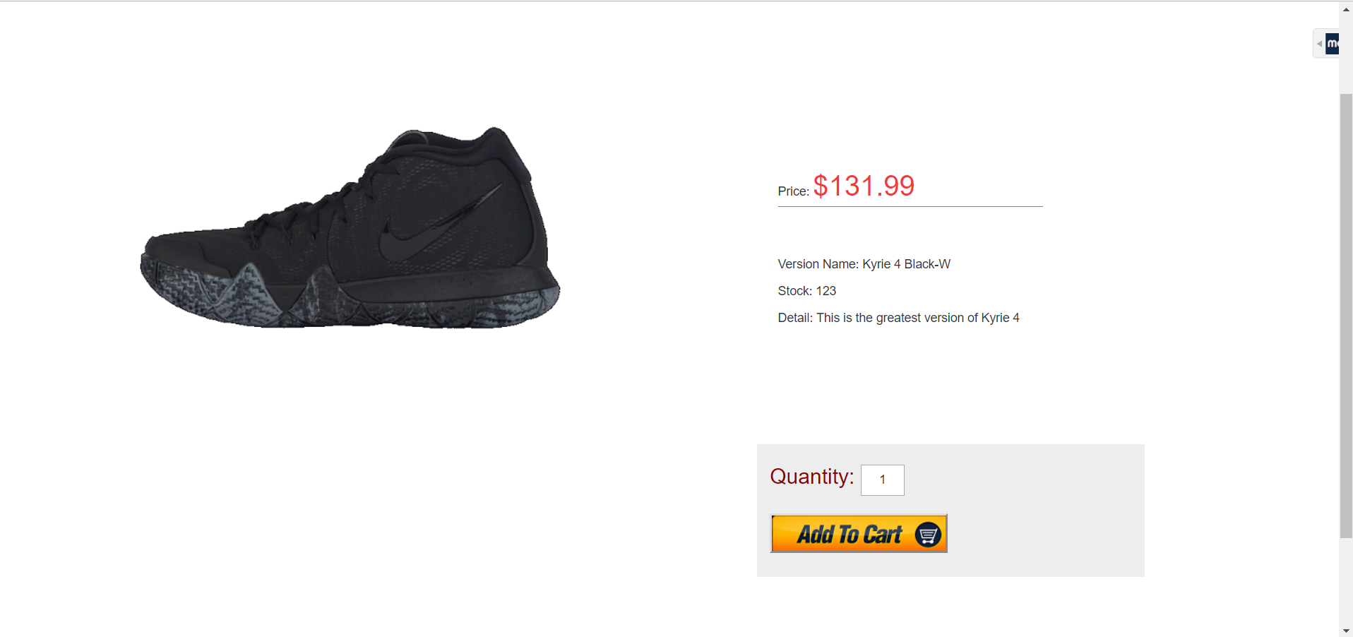

**Figure 5**

## 2.4 Search:

You can use the search function locates right of navigation bar for searching the item you want. Shown as figure 6.

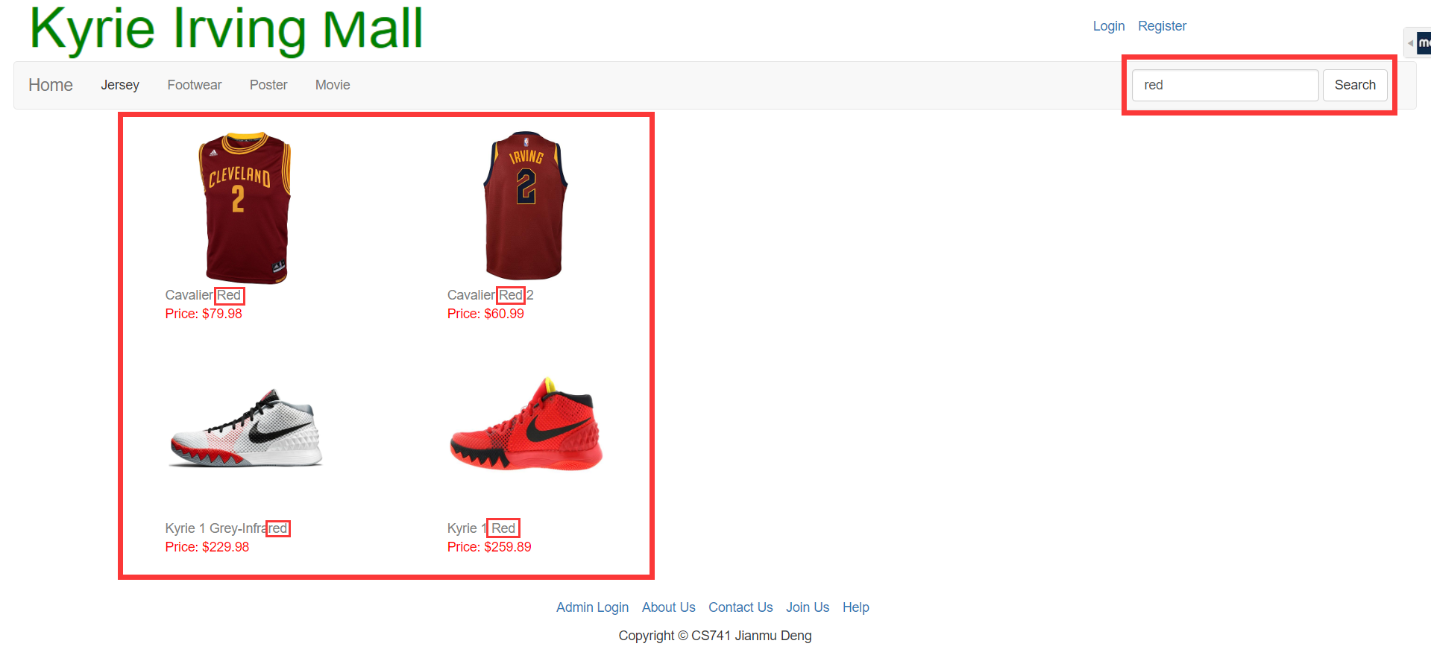

**Figure 6**

## 2.5 Cart:

You can click “Cart” link to view your cart. You can click check button to the next step. And you can change quantity for each item. If there is valid promotion, you can apply it. The system will give you corresponding discount. Shown as figure 7.

In next step, you can edit your profile. Shown as figure 8.

You can also change your profile when you click your username locates top right of each page after you login. Shown as figure 9.

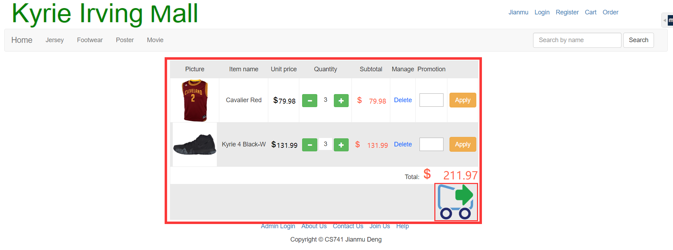

**Figure 7**

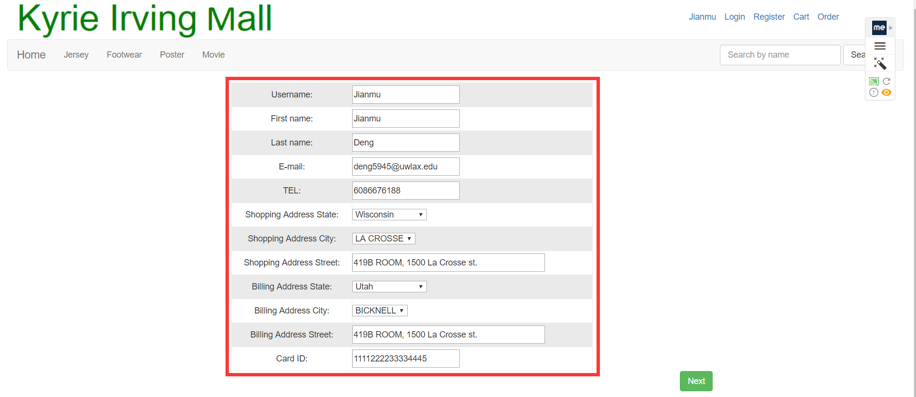

**Figure 8**

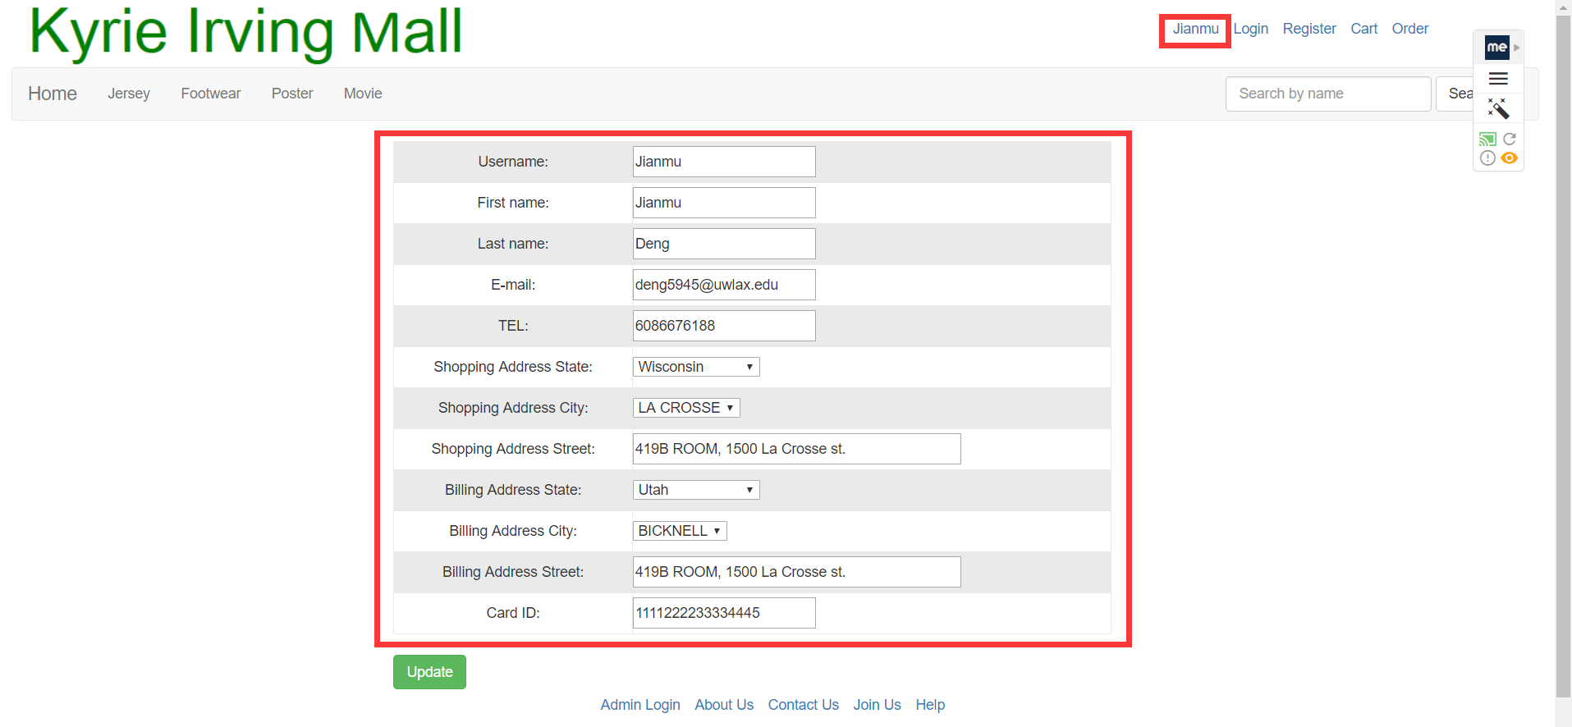

**Figure 9**

## 2.6 Purchase:

In the final step of purchase, you can got the discount of promote item. There will be the tax rate and total cost for this order. Shown as figure 10.

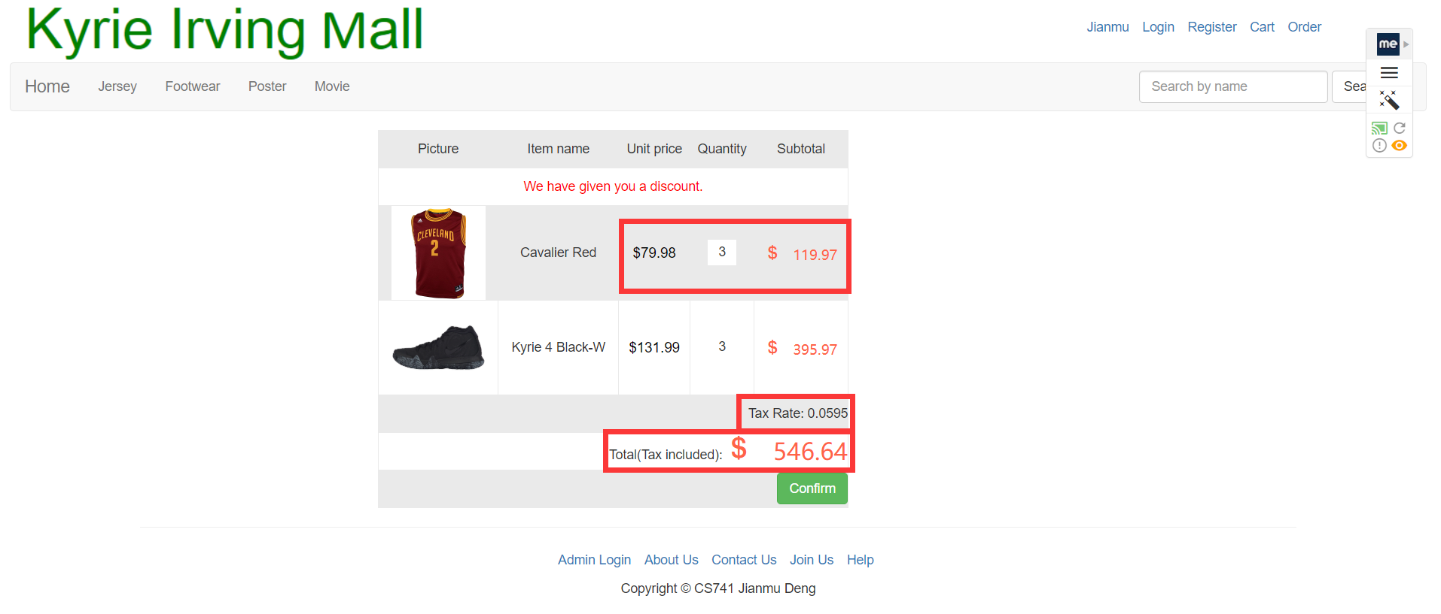

**Figure 10**

## 2.7 Order:

The history order will be generated after you confirm your purchase. You can click “Order” link locates top right of each page after you login to view all your history order. Shown as figure 11.

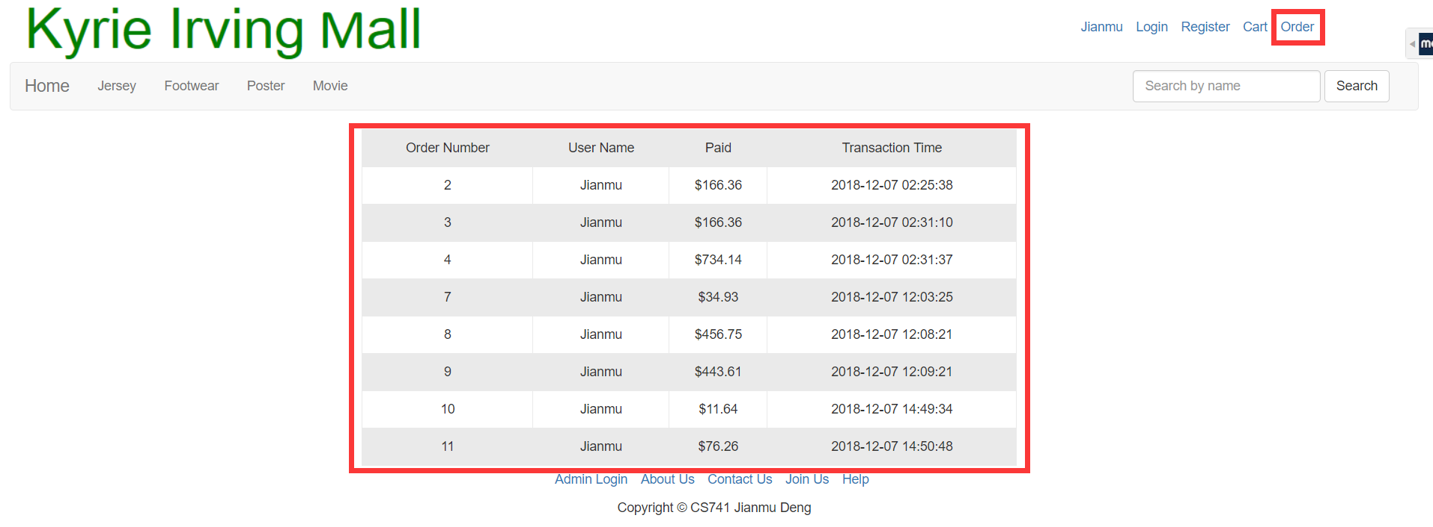

**Figure 11**

**If you still have question. Please contact our customer service: 1-(608)-667-6188.**

**Thank you again for choosing Kyrie Irving Mall.**